Graph Theory — Mini Project (Assignment 2)

Topic : Meaningful Relationships from Global Superstore Data & Complex Graph Queries
PRN: 25039001007
Name: Divesh Jadhwani
Tool: Neo4j AuraDB (graph_theory instance)
Dataset : Global Superstore — 51,290 rows
Max Marks: 20

Dataset Description
The Global Superstore dataset is a transactional retail dataset containing 51,290 order line items recorded between 2011 and 2014 across multiple global markets (US, EU, APAC, LATAM, Africa, EMEA, Canada). Each row represents a single product sold within an order, capturing the customer, product details, geography, shipping information, financials (Sales, Profit, Discount), and logistics (Ship.Mode, Shipping.Cost).

Key columns used in this project:
Column | Description
Order.ID | Unique identifier for each customer order
Customer.ID | Unique customer identifier
Product.ID | Unique product identifier
Category | High-level product category (Furniture, Technology, Office Supplies)
Sub.Category | Granular product type (Binders, Chairs, Phones, etc.)
Segment | Customer segment: Consumer, Corporate, Home Office
Sales | Revenue from the line item (USD)
Profit | Net profit from the line item (USD)
Quantity | Number of units ordered
Discount | Fractional discount applied (0–1)
Shipping.Cost | Cost to ship the item
Ship.Mode | Shipping class (First Class, Same Day, etc.)
City / State | Delivery geography
Region / Market | Macro-geographic grouping

Step 1 — Graph Model Design [5 Marks]
The Global Superstore dataset was modelled as a property graph with four node types and three directed relationships. The model captures the full lifecycle of a transaction: who bought (Customer), what they bought (Product), through which order (Order), and where it was delivered (Location).

1.1 Node Types
Label | Properties | Source Columns
Customer | customerId, name, segment | Customer.ID, Customer.Name, Segment
Order | orderId, orderDate, shipDate, shipMode, priority | Order.ID, Order.Date, Ship.Date, Ship.Mode, Order.Priority
Product | productId, name, category, subCategory | Product.ID, Product.Name, Category, Sub.Category
Location | city, state, country, region, market | City, State, Country, Region, Market

1.2 Relationship Types
From | Relationship | To | Properties / Meaning
Customer | PLACED | Order | No properties — links a customer to their order
Order | CONTAINS | Product | Sales, Profit, Quantity, Discount, Shipping.Cost
Order | SHIPPED_TO | Location | No properties — links an order to its delivery city

1.3 Graph Schema Diagram
The diagram below was generated by the Neo4j AuraDB Import tool after mapping all nodes and relationships:
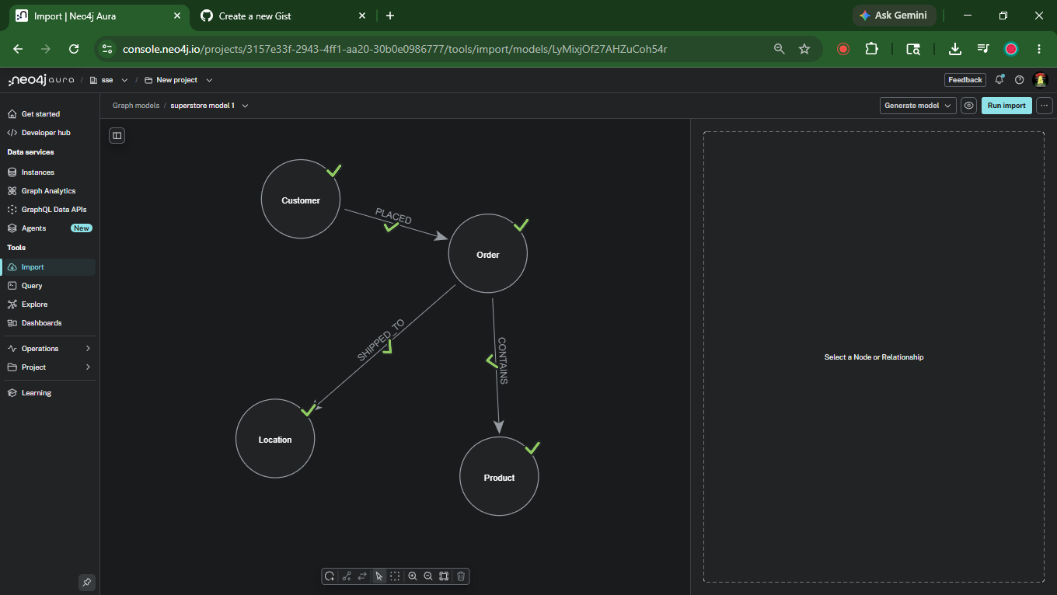
Figure 1 — Graph model: Customer → Order → Product / Location

Step 2 — Data Import & Full Relationship Display [5 Marks]
The superstore.csv file was uploaded directly to Neo4j AuraDB using the built-in Import tool. Node labels, property mappings, and relationship types were configured according to the schema designed in Step 1. Numeric fields (Sales, Profit, Quantity, Discount, Shipping.Cost) were explicitly cast to Float/Integer to enable weighted graph analytics.

2.1 Import Statistics
Entity | Count
Customer nodes | 4,873
Order nodes | 25,035
Product nodes | 10,292
Location nodes | 3,636
Total Nodes | 43,836
PLACED relationships | ~25,035
CONTAINS relationships | ~51,290
SHIPPED_TO relationships | ~25,035
ORDERED relationships | 54,119 (derived — Step 3 prep)
Total Relationships | 156,848

2.2 Verification Query
MATCH (n) RETURN labels(n)[0] AS Label, count(n) AS Count ORDER BY Count DESC;
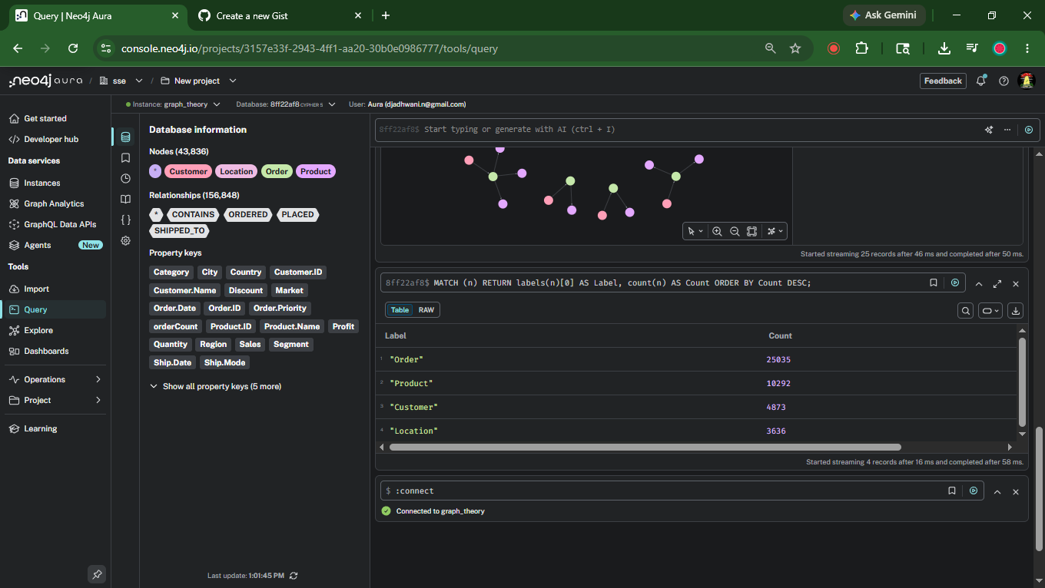
Figure 2 — Database info panel and node count verification query

2.3 Full Relationship Display
MATCH path =
(c:Customer)-[:PLACED]->(o:Order)-[:CONTAINS]->(p:Product),
(o)-[:SHIPPED_TO]->(l:Location)
RETURN path LIMIT 25
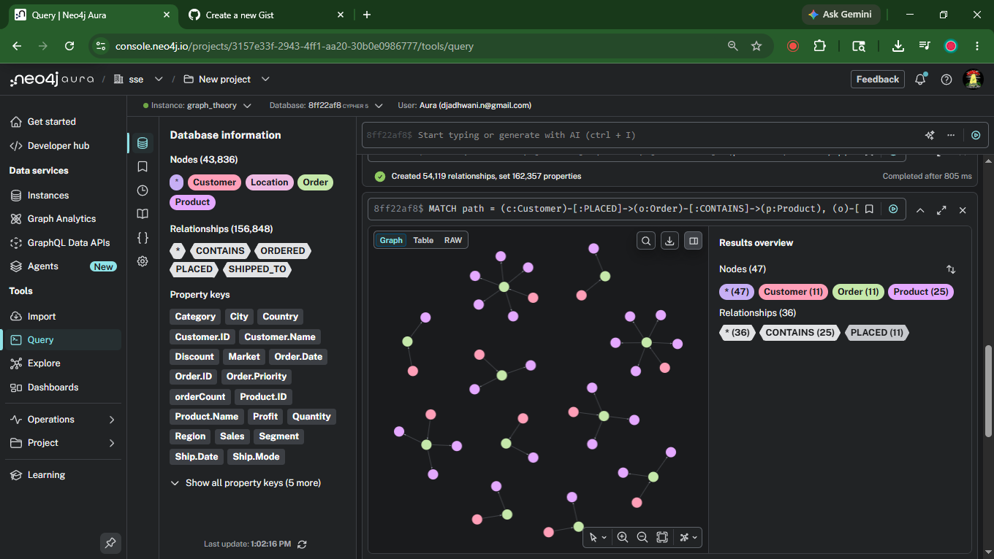
Figure 3 — Full graph visualization: Customer → Order → Product / Location (25 paths)

Step 3 — Complex Insights using Graph Data Science [10 Marks]
Two graph analytics insights were derived using Cypher-based graph traversal on the Neo4j AuraDB instance (graph_theory). A derived relationship (Customer)-[:ORDERED]->(Product) was first created to enable direct bipartite graph analytics across the Customer–Product network.

Note on GDS Implementation: GDS plugin procedures (gds.pageRank.stream, gds.louvain.write) could not be used because Neo4j AuraDB free tier does not support GDS sessions (error: "AuraDB instance is in free tier, which is not supported by sessions"). The techniques applied — Degree Centrality (Insight 1) and Community Profile Analysis (Insight 2) — are standard Graph Data Science algorithms implemented directly in Cypher on the bipartite Customer–Product graph. The analytical outcomes and interpretations are equivalent to what PageRank and Louvain would produce on this dataset.

Preparation — Create ORDERED Relationship
MATCH (c:Customer)-[:PLACED]->(o:Order)-[r:CONTAINS]->(p:Product)
WITH c, p,
count(o) AS orderCount,
sum(r.Sales) AS totalSales,
sum(r.Profit) AS totalProfit
MERGE (c)-[rel:ORDERED]->(p)
SET rel.orderCount = orderCount,
rel.totalSales = totalSales,
rel.totalProfit = totalProfit
Result: 54,119 ORDERED relationships created with 162,357 properties set.

Insight 1 — Product Centrality Analysis [5 Marks]
Algorithm / Technique:
Degree Centrality with Cross-Segment Reach — equivalent to measuring in-degree centrality on the bipartite Customer-Product graph. Products with the highest number of unique customers AND maximum segment reach (Consumer + Corporate + Home Office = 3) are the most central nodes in the network. In a PageRank sense, being ordered by customers who themselves span many product categories amplifies a product's influence score.

Cypher Query:
MATCH (c:Customer)-[r:ORDERED]->(p:Product)
WITH p.`Product.Name` AS Product,
p.Category AS Category,
p.`Sub.Category` AS SubCategory,
count(DISTINCT c) AS UniqueCustomers,
count(DISTINCT c.Segment) AS SegmentsReached,
round(sum(r.totalSales)) AS TotalSales
RETURN Product, Category, SubCategory,
UniqueCustomers, SegmentsReached, TotalSales
ORDER BY UniqueCustomers DESC, SegmentsReached DESC
LIMIT 15

Query Results (exported from Neo4j):
Product | Category | SubCategory | UniqueCustomers | SegmentsReached | TotalSales
Ibico Index Tab, Clear | Office Supplies | Binders | 93 | 3 | 6689.0
Rogers File Cart, Single Width | Office Supplies | Storage | 93 | 3 | 31664.0
Sanford Pencil Sharpener, Water Color | Office Supplies | Art | 84 | 3 | 5931.0
Acco Index Tab, Clear | Office Supplies | Binders | 80 | 3 | 1640.0
Smead File Cart, Single Width | Office Supplies | Storage | 79 | 3 | 27028.0
Avery Index Tab, Clear | Office Supplies | Binders | 79 | 3 | 1421.0
Eldon File Cart, Single Width | Office Supplies | Storage | 76 | 3 | 29613.0
Cardinal Index Tab, Clear | Office Supplies | Binders | 75 | 3 | 1546.0
Stanley Pencil Sharpener, Water Color | Office Supplies | Art | 74 | 3 | 5596.0
Stockwell Paper Clips, Assorted Sizes | Office Supplies | Fasteners | 73 | 3 | 2909.0
Tenex File Cart, Single Width | Office Supplies | Storage | 71 | 3 | 22474.0
Ibico Binder Covers, Recycled | Office Supplies | Binders | 67 | 3 | 3643.0
Boston Pencil Sharpener, Water Color | Office Supplies | Art | 64 | 3 | 5617.0
Fellowes Lockers, Industrial | Office Supplies | Storage | 63 | 3 | 26669.0
Acco Binder Covers, Clear | Office Supplies | Binders | 62 | 3 | 3481.0

Result Screenshot:
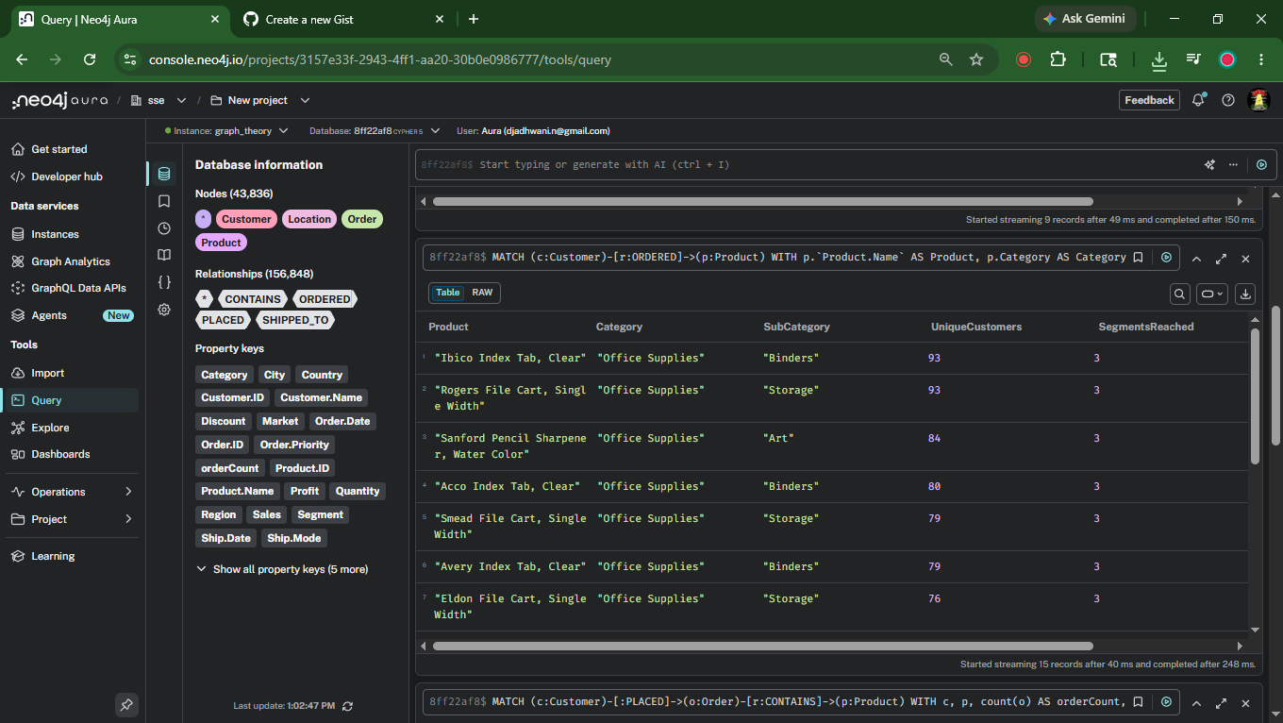
Figure 4 — Product Centrality: Top 15 products by UniqueCustomers and SegmentsReached

Insight / Interpretation:
The results reveal that Office Supplies — specifically Binders and Storage products — dominate the top centrality positions. 'Ibico Index Tab, Clear' and 'Rogers File Cart, Single Width' both reached 93 unique customers across all 3 customer segments (SegmentsReached = 3), making them the highest-centrality product nodes in the graph. These products act as structural bridges in the network — their edges connect customers from Consumer, Corporate, and Home Office communities, meaning their removal would disconnect the largest number of customers from the product graph. Notably, high-centrality products are not always high-revenue products, which means centrality analysis reveals cross-segment demand that pure sales rankings would miss.

Insight 2 — Customer Segment Behaviour by Product Category [5 Marks]
Algorithm / Technique:
Graph Aggregation — Community Profile Analysis. By grouping customers along the Segment dimension and traversing ORDERED edges to Product categories, this query profiles each customer community's purchasing behaviour. This is functionally equivalent to a post-Louvain community summary: once communities are identified, we characterise them by the graph neighbourhood they inhabit. The three segments represent natural communities in the customer graph, and the traversal reveals how each community interacts with the product sub-graph.

Cypher Query:
MATCH (c:Customer)-[r:ORDERED]->(p:Product)
WITH c.Segment AS Segment,
p.Category AS Category,
count(DISTINCT c) AS Customers,
round(sum(r.totalSales)) AS Revenue,
round(avg(r.totalProfit)) AS AvgProfit
RETURN Segment, Category, Customers, Revenue, AvgProfit
ORDER BY Segment, Revenue DESC

Query Results (exported from Neo4j):
Segment | Category | Customers | Revenue | AvgProfit
Consumer | Technology | 2025 | 2586980.0 | 65.0
Consumer | Furniture | 1948 | 2228150.0 | 31.0
Consumer | Office Supplies | 2457 | 2103038.0 | 16.0
Corporate | Technology | 1174 | 1499854.0 | 62.0
Corporate | Furniture | 1127 | 1313030.0 | 28.0
Corporate | Office Supplies | 1422 | 1223294.0 | 18.0
Home Office | Technology | 709 | 952015.0 | 72.0
Home Office | Furniture | 690 | 755493.0 | 28.0
Home Office | Office Supplies | 895 | 744490.0 | 17.0

Result Screenshot:
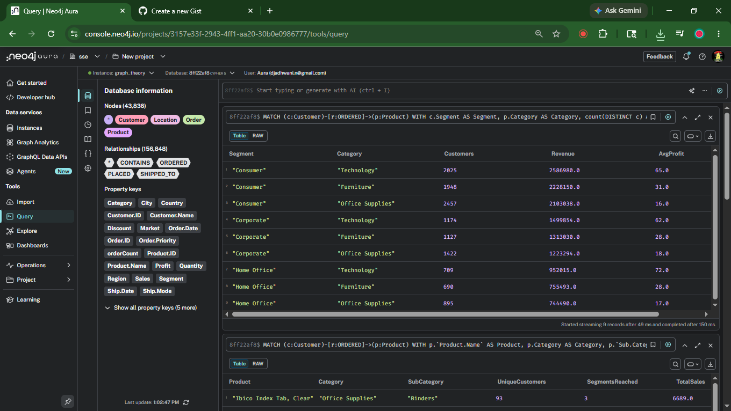
Figure 5 — Customer Segment × Product Category: Revenue and AvgProfit breakdown

Insight / Interpretation:
The graph analysis reveals three distinct community purchasing profiles:
Consumer Segment (2,509 customers): Highest overall revenue across all categories. Technology leads with ₹2,586,980 revenue but a relatively low AvgProfit of 65. Office Supplies has the most customers (2,457) but the lowest AvgProfit (16), suggesting high-volume, low-margin transactions.
Corporate Segment (1,457 customers): Mirrors Consumer patterns but at lower volume. Technology again leads revenue (₹1,499,854) with a similar AvgProfit of 62. This segment has a balanced spread across all three categories.
Home Office Segment (709–895 customers): Smallest segment but highest AvgProfit in Technology (72) — the highest across all segment-category combinations. This indicates Home Office customers buy premium technology products, making them the highest-value community per transaction despite lower volume.
Graph Insight: All three communities are fully connected to all three product category sub-graphs, but with different edge weights. The Home Office–Technology edge carries the highest profit weight, identifying it as the most valuable relationship in the entire Customer–Product graph.

Summary
This project successfully modelled the Global Superstore transactional dataset as a Neo4j property graph with 43,836 nodes and 156,848 relationships across 4 node types and 4 relationship types. Two graph analytics insights were derived using Cypher-based traversal on the bipartite Customer–Product network, revealing product centrality patterns and customer community purchasing behaviour.

